2. Execute and display the results for the following commands in Kali Linux Operating Systems:
less command
more command
vi command

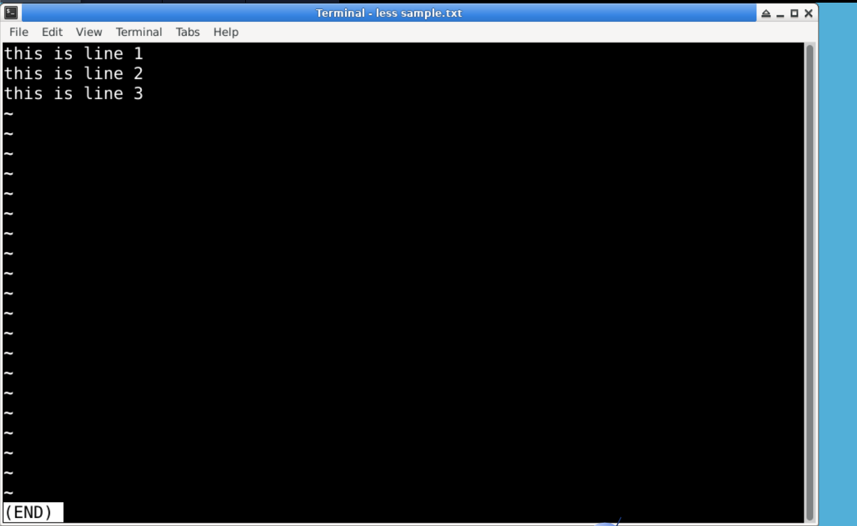
This is less command
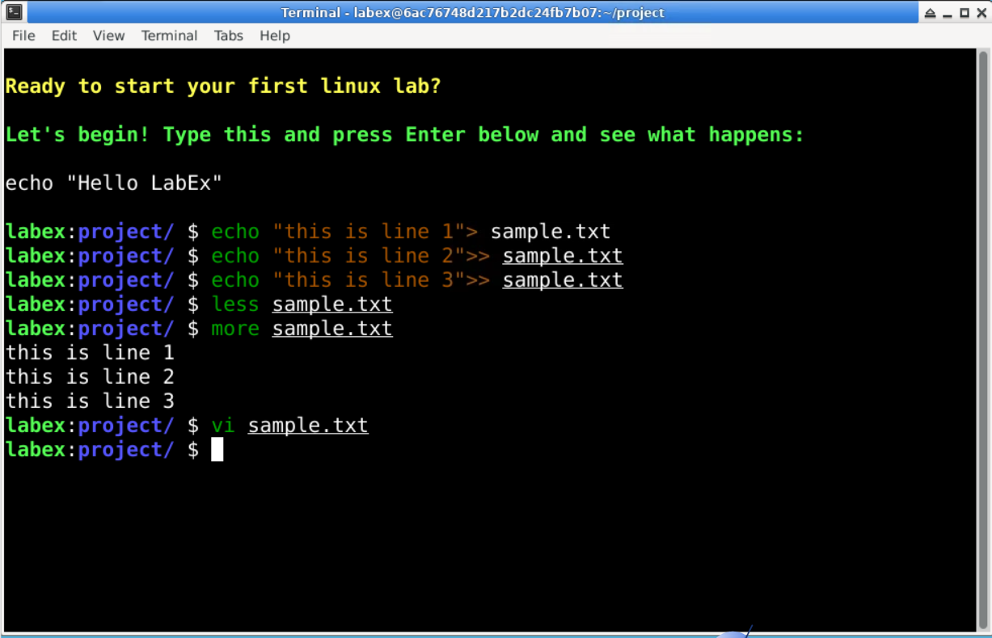
This is more command
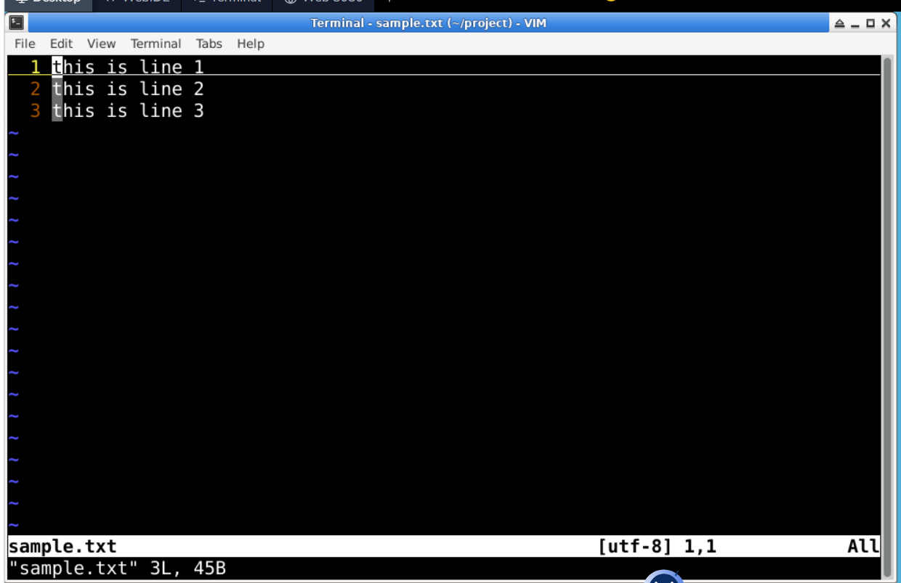
This is vi command

